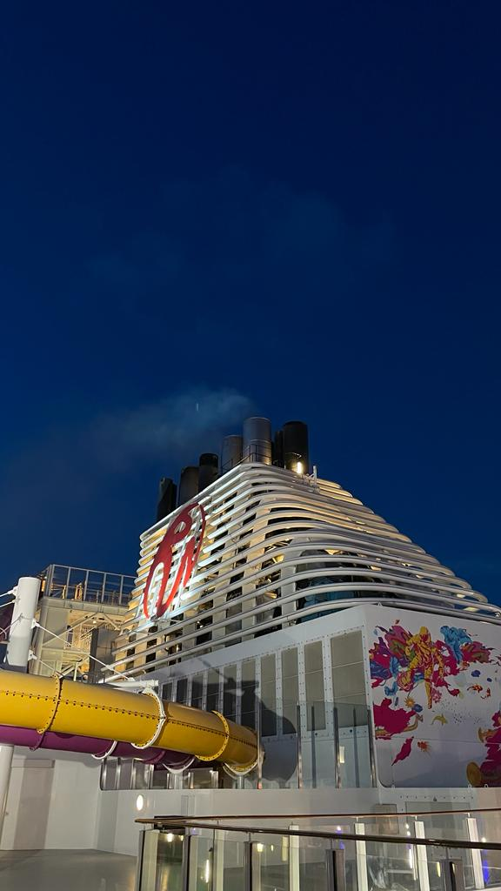**Title: "My Unforgettable 5 Days 4 Night Cruise Adventure" (Resort World Cruise)**

**Introduction:**  
  
Embarking on the Resort World Cruise was a dream come true for me. From the moment I stepped foot on the magnificent Genting Dream, I knew I was in for an extraordinary journey. Are you guys excited about my unforgettable cruise adventure? Let me bring it to you!

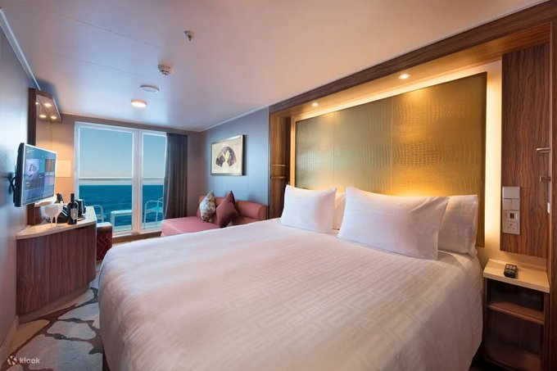**Firstly, What Do We Have?**  
  
We have a good-looking and well-mannered cabin crew surrounded by world-class entertainment. After a tiring and long day, I walked into my balcony stateroom cabin. I was immediately captivated by the handsome ocean view. The clean and spacious cabin balcony is the top A-list for me. Why? From the bedroom to the bathroom, everything is top-notch.

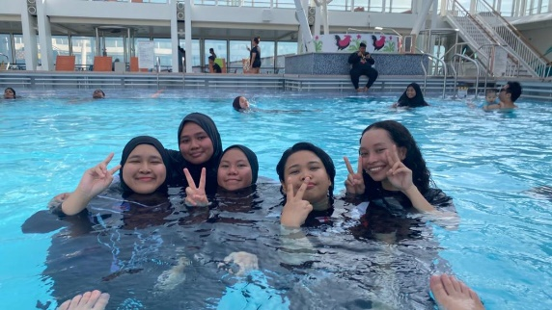

**Secondly, The Waiting Part Is The Endless Fun And Adventure Moments**.  
  
 Everyone is excited about FREE! Whether it is free entertainment, free gifts, or free activities, I'm sure you are one of them. All of these incredible activities were included for free, ensuring that there was something for everyone to enjoy. There are waterslides, rock climbing walls, futsal, and ping pong. So, there was never a dull moment. I thought the activities would end there, but there were more exciting parts. GUESS WHAT? The swimming pool was accompanied by a cool DJ, a cool song, and a cool dance. Moreover, you can test your adrenaline junkies with waterslides and jacuzzies.   
  
  
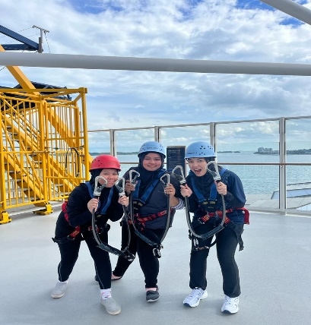For outdoor lovers, you can also enjoy activities like rope courses, it's also for free. From the mesmerizing Infinite Show, a dance extravaganza reminiscent of America's Got Talent, to the engaging and hilarious Love Matters performance, every night was filled with excitement and wonder. It's really perfect for solo travel and family.

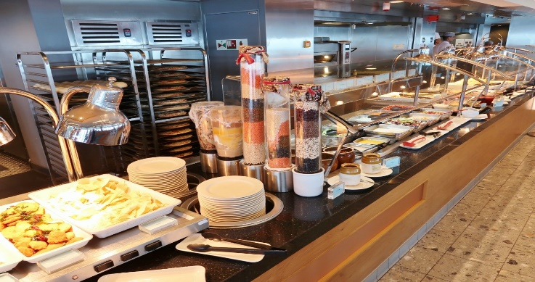**A Foodie Delights In A Masterpiece.**  
  
The Lido restaurant will provide you with never-ending appetite satisfaction from the dessert, main menu, and, of course, Halal food. It's perfect for Muslim travelers. The most mouthwatering is Asam Pedas, cooked by an A-class chef. Every time you want to fill an empty stomach, food is served at a delightful buffet. It covers breakfast, lunch, and dinner. In addition, they also have a snack bar for you to spend your leisure time with friends and family.

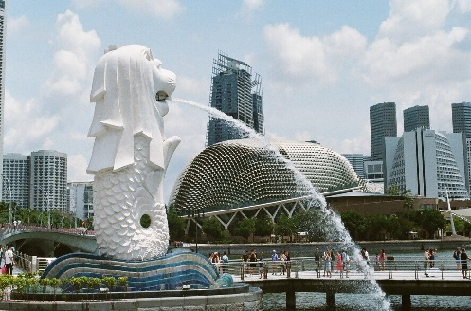**Exploring Lion City,**  
  
That sounds like a wonderful plan! When you dock at the Singapore Marina Bay Port, you can explore amazing places like Merlion Park, Arab Street, and even Changi Airport. These destinations offer unique experiences and sights to discover. If you're up for it, you can join a shore excursion to make the most of your time in Singapore. Just remember to book the excursion once you're on board the ship. Have a fantastic adventure!

In conclusion, travel with Resort World Cruise Genting is not just a journey to new places, it’s a voyage of self-discovery, cultural excitement, and lifelong memories. So, don’t forget to book your adventure with us. Let's start your adventure with us “KAKI JALAN”. See you onboard people!!!!!!  
  
 Written Memories by  
 Nurul Zakirah 10/9/2023